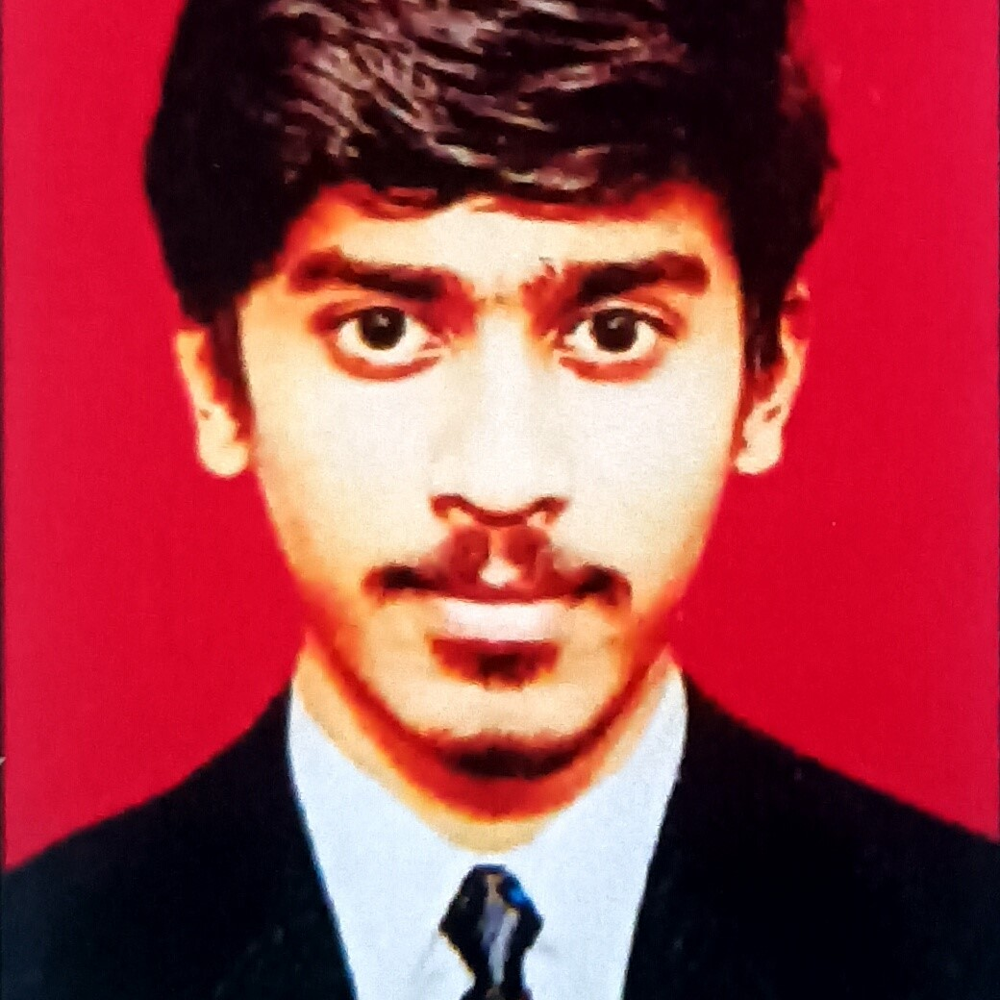

HARI PRASAD SAHOO

**JAVA DEVELOPER**



Contact

Address: Mahape, Navi Mumbai,

Maharashtra

Mobile: 9348933134

Email: sahoohari222@gmail.com

Date of Birth: 01/03/1999

Marital Status: single

Nationality: Indian

Linkedin: [www.linkedin.com/in/hari-](http://www.linkedin.com/in/hari-) sahoo-3462aa24a/



Languages

Odia

Hindi

English



Skills

Microsoft office

Java

Spring

HTML

CSS

MySQL



Objective

I am a hardworking and ambitious individual with a great passion for the

transport and logistics industry. I have done my BA economics degree at

North Orissa University. I have excellent communication skills, enabling

me to effectively communicate with a wide range of people. I am seeing a

full-time position in the industry in which I can put into practice my

knowledge and experience, ultimately benefiting the operations of the

organisation that I work for.



Experiences

Computer Operator

Jun2021

-

Sep2021

**Progress Biotech**

Printing order invoice . Maintaining products . Data

entry . Another computer related work

Branch General and

administrative

Sep2021

-

Feb2022

**Kesineni Cargo**

Maintaining an up-to-date database of all the

institution's vehicles. . Maintaining proper inventory of

all components of vehicles. . Making sure they are

maintained and checking frequently. . Logistic booking

and tracking

Help Desk ( Customer

service)

Feb2022

-

Dec2022

**AGS Transact Technologies Ltd**

Respond to requests for technical assistance in person,

via phone, chat or mail. . Advise user on appropriate

action. . Follow standard help desk procedures. . Log all

help desk interaction. . Follow up with customers and

users to ensure complete resolution of issues. .

Redirect problems to correct resource. . Identify and

escalate situations requiring urgent attention. . Track

and route problem and request and document

resolution. . Prepare activity report. . Inform

management of recurring problems. . Stay current with

system information, changes and updates

Customer service

Dec2022

-

Present

**NOVAC Technology Solutions**

I work in customer care process of Shriram housing

finance and I take calls for inbound and outbound cross

verification, reminder, section, etc. 1. Maintaining a

positive, empathetic, and professional attitude towards

customer at all times. 3. Responding promptly to

customer inquires. 4. Communicating with customer

|  |  |
| --- | --- |
| Javascript | through various channels. 5. Acknowledging and resolving customer complaints. 6. Knowing our products inside and out so that you can answer questions.  Education |
| Interest |
| **I.A U.N College, Nalagaja, Odisha**  **2015-2017**  **B.A Economic (Honours) North orisha university**  **2017-2021**  **Master of Full Stack IT Vedant**  **Web Development**  **2023-Present**  Project |
| Drawing  Gaming  Reading  Music  Traveling  Learn to new things |
| **Blood Bank Management System**  I created this project after 'MySQL' was finished. And it made for my class presentation.  This project aims at maintaining all the information pertaining to blood donors, different blood groups available in each blood bank and help them manage in a better way. Aim is to provide transparency in this field, make the process of obtaining blood from a blood bank hassles free and corruption free and make the process of obtaining blood bank management effective.  **Portfolio**  I created this using 'HTML', 'CS', and 'JavaScript' for the class project.  I made it for myself.  **Library Management System**  This is my Java project. I created it using 'Java', 'Spring', and 'MySQL'. It has been created by adding mapping, security, controller, service, and more.  project is software that organizes and saves books and information electronically to meet the needs of libraries. Book borrowers and library personnel benefit from the system. It allows them to keep track of all of the books available in the library at all times. The administrator and the student were also allowed to look for the book they needed.    HARI PRASAD SAHOO |